Practical – 02
Code:
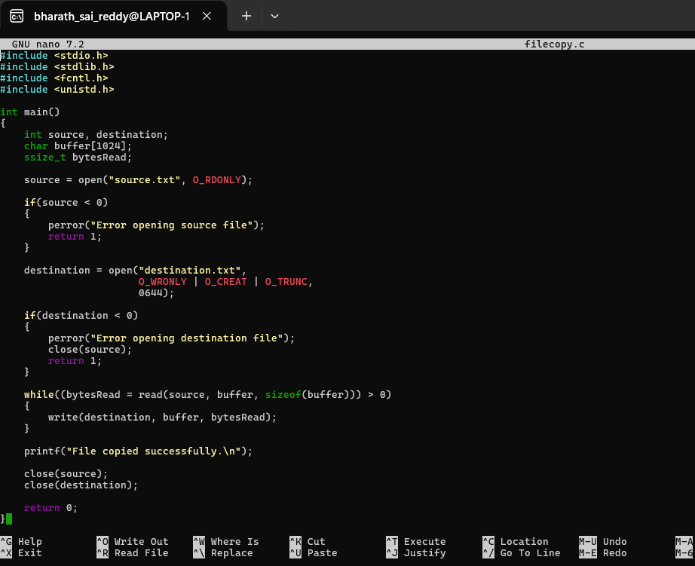
Output:
A:
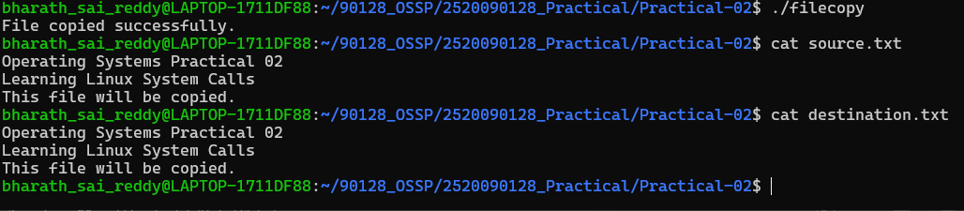
B:
